**CLOUD COMPUTING DAY-3 QUESTIONS**

**USING AZURE**

**17. Demonstrate Storage as a Service (SaaS) create and configure a new VM Image in any Public Cloud Service Provider Procedure:**

1.To got storage accounts.

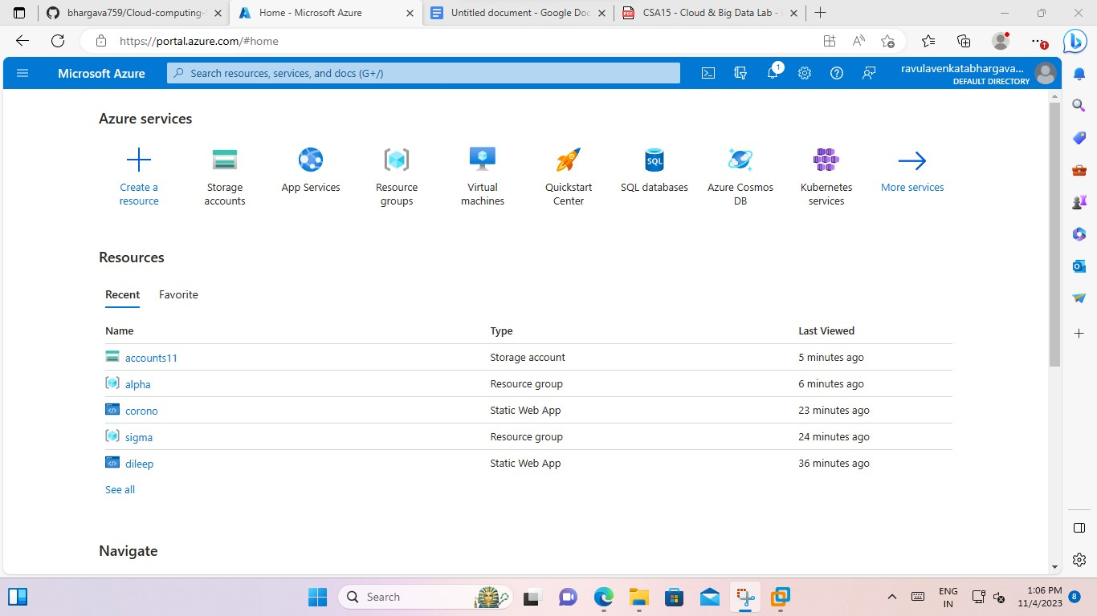

2.To create an accounts.

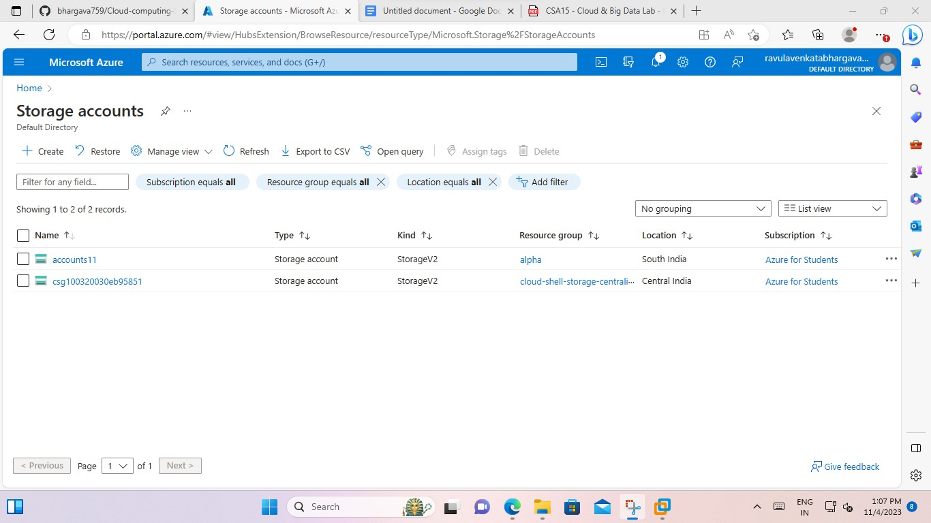

3.->To open a basics.

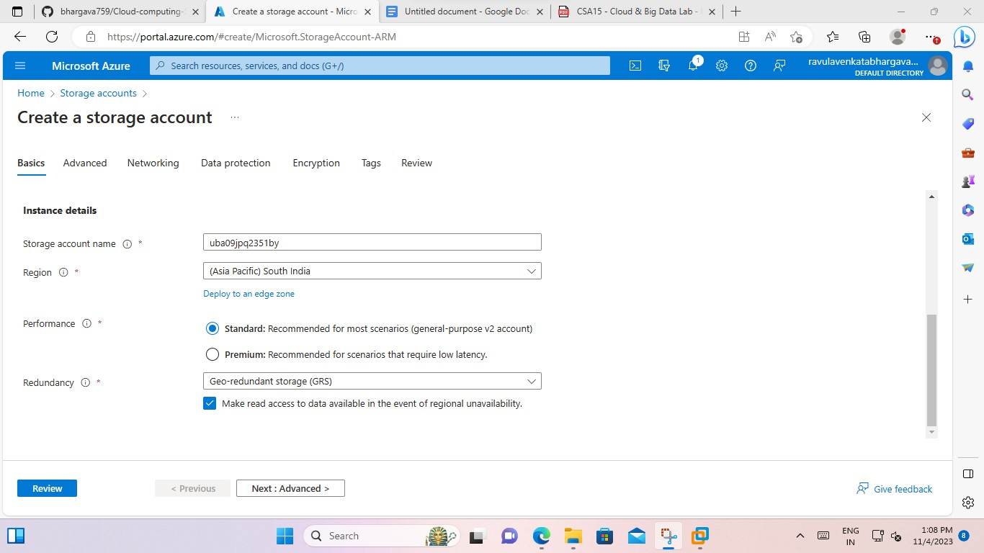

**-**> To open advanced option after basics.

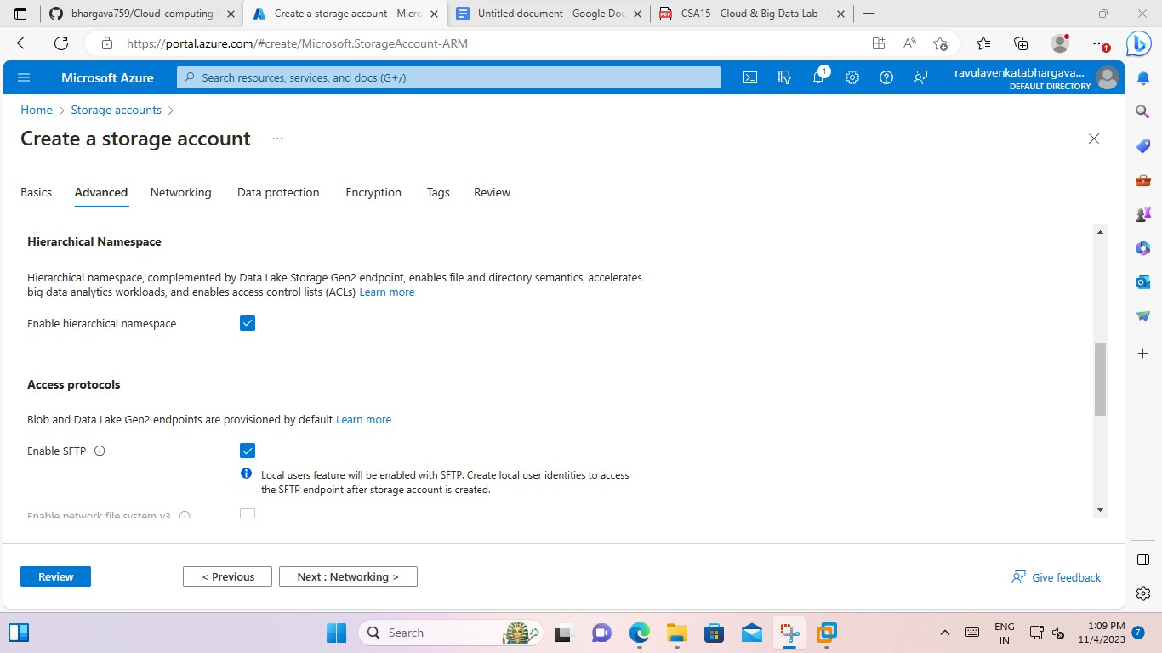

-> To open networking.

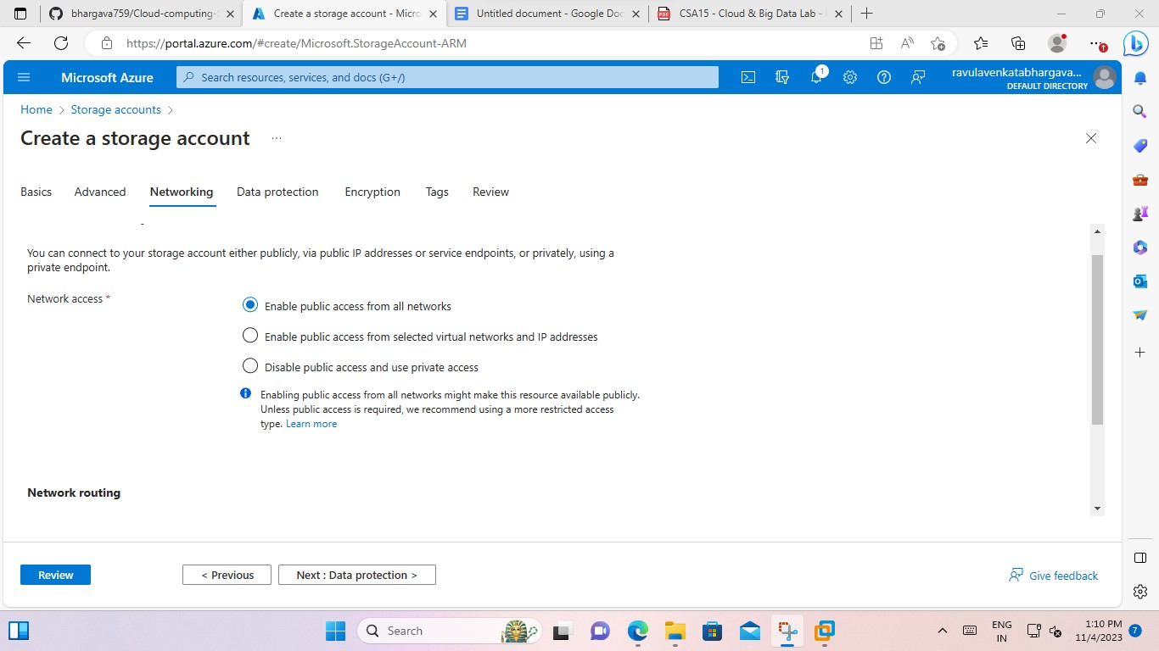

->To open data protection.

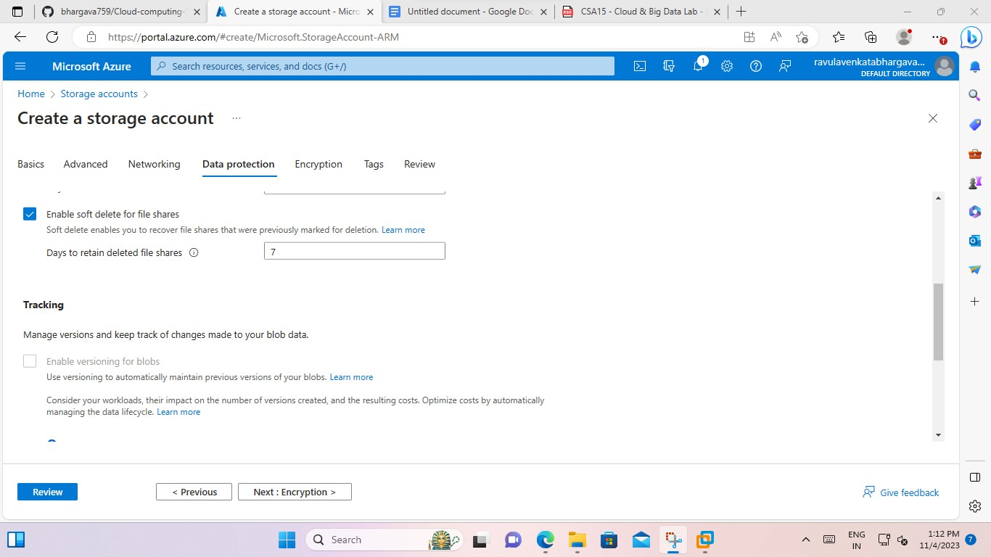

-> to open encryption.

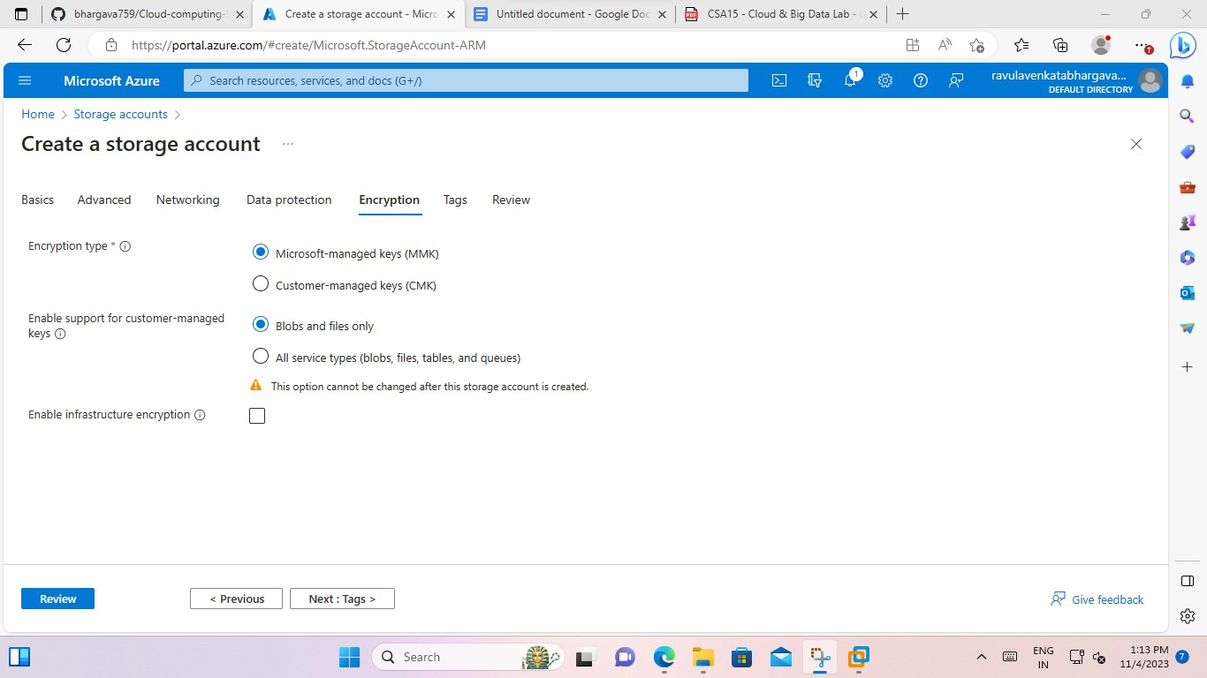

-> to open tags and give the any.

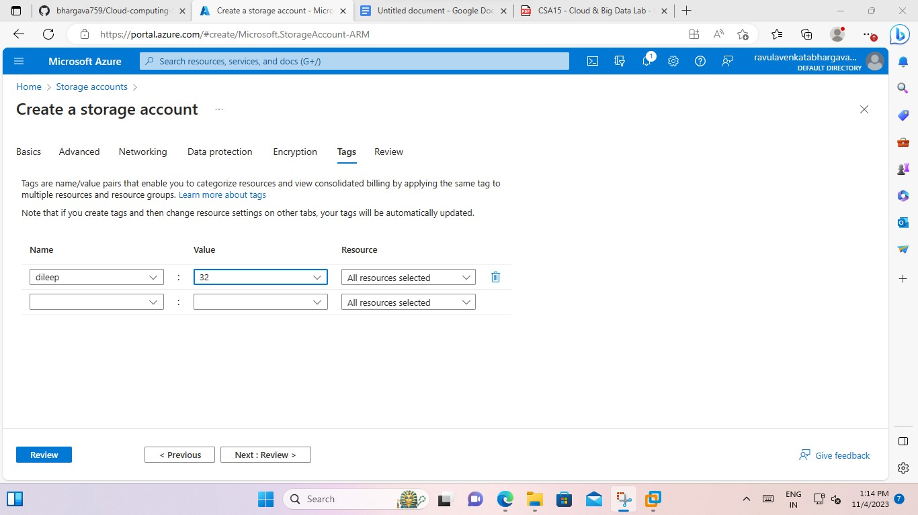

->After creation of storage account.

